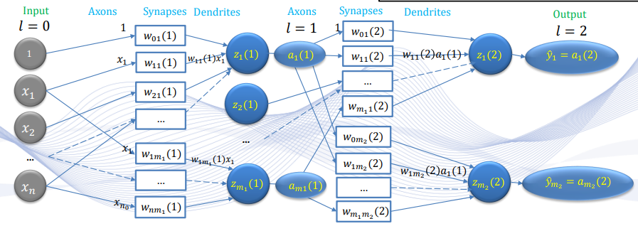

Define $a_{i}^{\left(0\right)}=x_{i}$ and $a_{k}^{\left(2\right)}={\hat{y}}_{k}$.

**Forward Feeding**

$$z_{j}^{\left(1\right)}=\sum_{i=1}^{m_{0}}{w_{ij}^{\left(1\right)}x_{i}}+b_{j}^{\left(1\right)}, a_{j}^{\left(1\right)}=f\left(z_{j}^{\left(1\right)}\right)$$

$$z_{k}^{\left(2\right)}=\sum_{j=0}^{m_{1}}{w_{jk}^{\left(2\right)}z_{j}^{\left(1\right)}}+b_{k}^{\left(2\right)}, {\hat{y}}_{k}=f\left(z_{k}^{\left(2\right)}\right)$$

where we adopt the sigmoid function

$$f\left(x\right)=\frac{1}{1+e^{-x}}$$

**Back Propagation**

We use an improper gradient notation

$$∇_{w_{ij}^{\left(l\right)}}L=\frac{∂L}{∂w_{ij}^{l}}$$

MSE Loss Function:

$$L=\frac{1}{2}\sum_{k=1}^{m_{2}}{{\left({\hat{y}}_{k}-y_{k}\right)}^{2}}$$

For output layer (layer 2),

$$δ_{k}=\left({\hat{y}}_{k}-y_{k}\right){\hat{y}}_{k}\left(1-{\hat{y}}_{k}\right)$$

$$w_{jk}^{\left(2\right)}←w_{jk}^{\left(2\right)}-η\left[∇_{w_{jk}^{\left(2\right)}}L\right], ∇_{w_{jk}^{\left(2\right)}}L=δ_{k}a_{j}^{\left(1\right)}$$

$$b_{k}^{\left(2\right)}←b_{k}^{\left(2\right)}-η\left[∇_{b_{k}^{\left(2\right)}}L\right], ∇_{b_{k}^{\left(2\right)}}L=δ_{k}$$

For hidden layer (layer 1),

$$δ_{j}=a_{j}^{\left(1\right)}\left(1-a_{j}^{\left(1\right)}\right)\sum_{i=1}^{m_{2}}{δ_{k}w_{jk}^{\left(2\right)}}$$

$$w_{ij}^{\left(1\right)}←w_{ij}^{\left(1\right)}-η\left[∇_{w_{ij}^{\left(1\right)}}L\right], ∇_{w_{ij}^{\left(1\right)}}L=δ_{j}x_{i}$$

$$b_{j}^{\left(1\right)}←b_{j}^{\left(1\right)}-η\left[∇_{b_{j}^{\left(1\right)}}L\right], ∇_{b_{j}^{\left(1\right)}}L=δ_{j}$$

**Derivation**

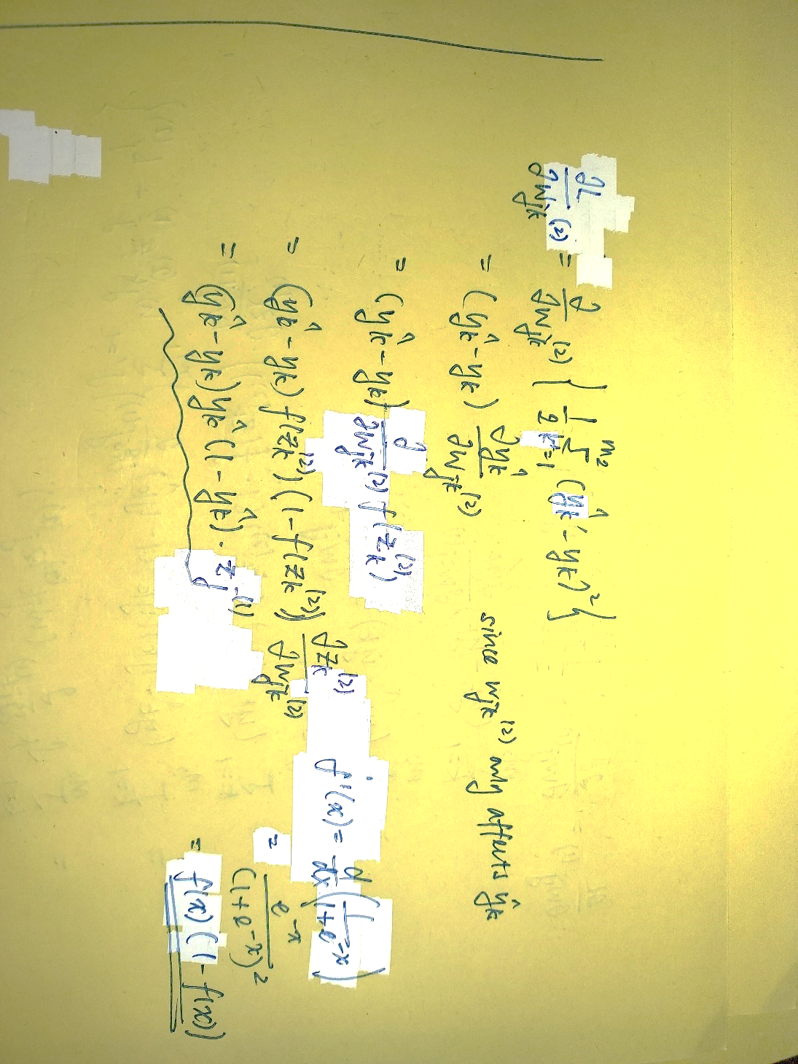

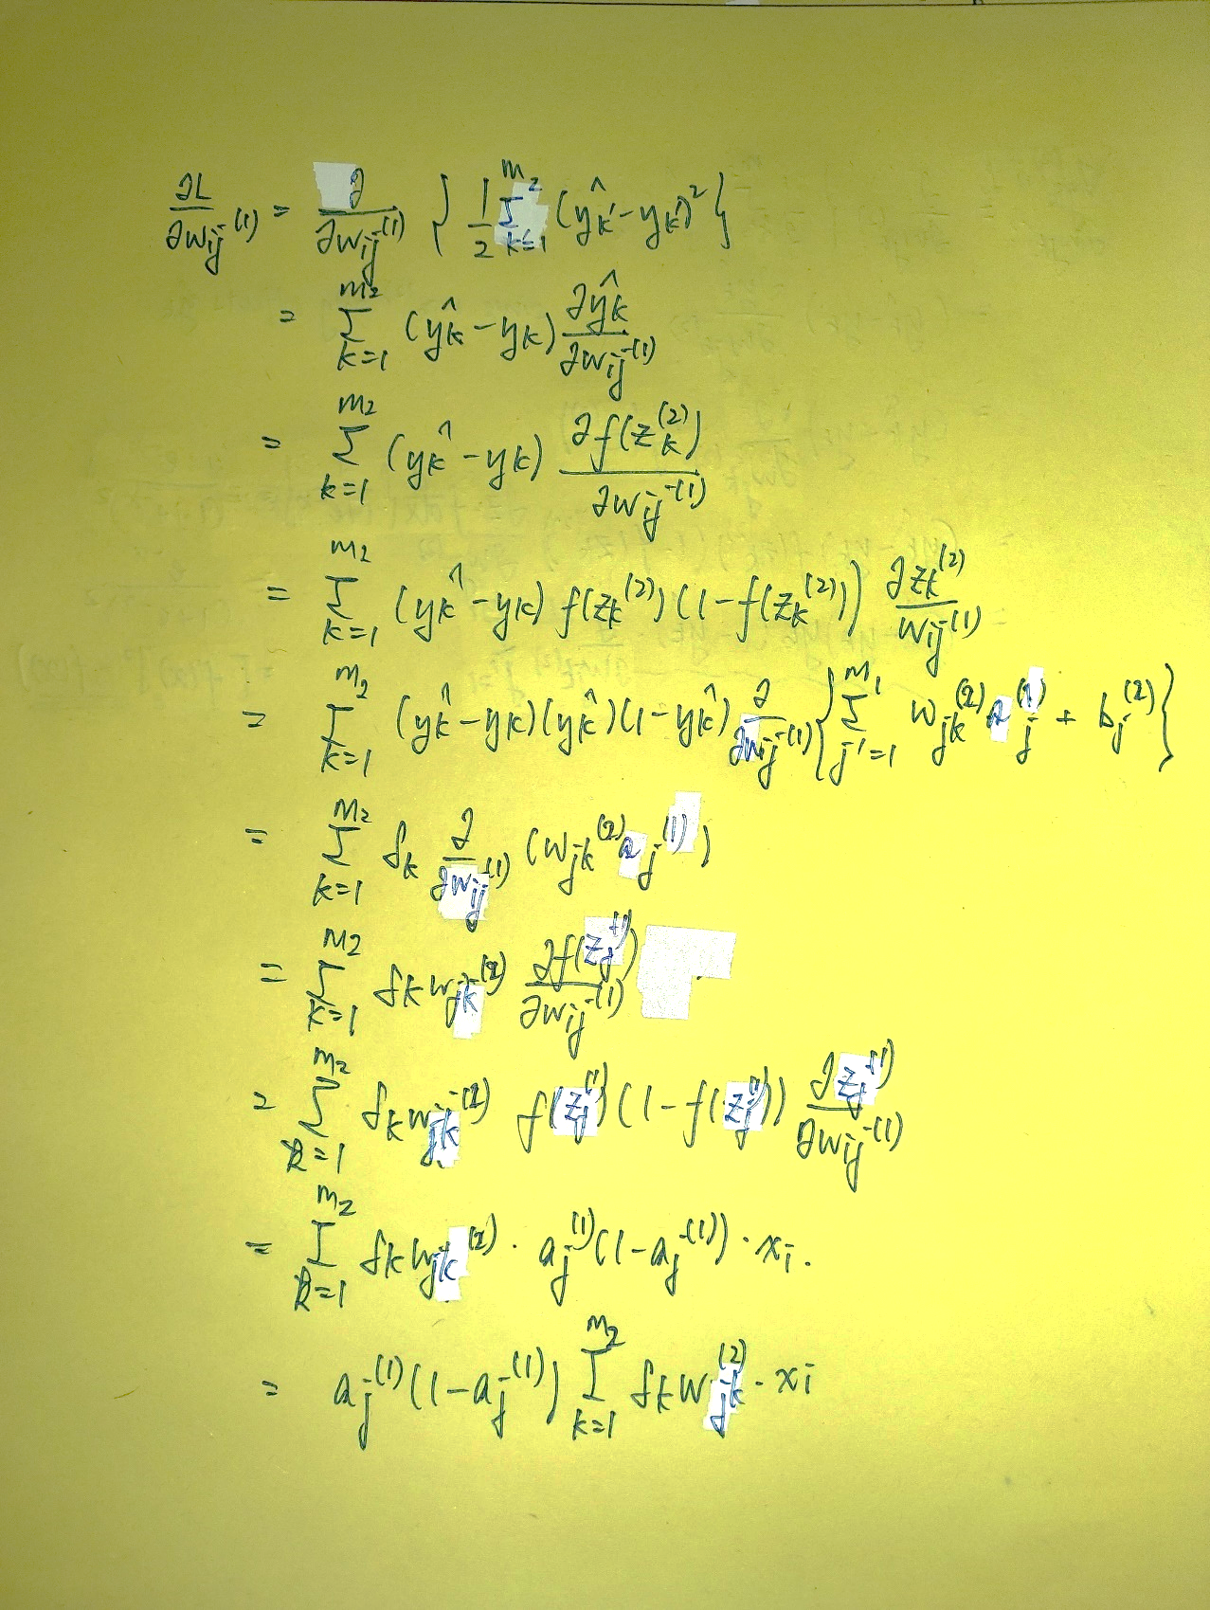

*Q1.5*

[*https://www.cs.cmu.edu/~aarti/Class/10315_Spring22/315S22_Rec4.pdf*](https://www.cs.cmu.edu/~aarti/Class/10315_Spring22/315S22_Rec4.pdf)

$$y=x^{T}W+b$$

$$y_{j}=\sum_{i=1}^{d}{x_{i}W_{ij}+b_{j}}$$

$J$*is a function of $y_{j}$ ($j=1,2,…,k$)*

$$\frac{∂J}{∂W_{ij}}=\sum_{j'=1}^{k}{\frac{∂J}{∂y_{j'}}\frac{∂y_{j'}}{∂W_{ij}}}=δ_{j}\frac{∂}{∂W_{ij}}\left(\sum_{i=1}^{d}{x_{i}W_{ij}+b_{j}}\right)=δ_{j}x_{i}$$

$$\frac{∂J}{∂x_{i}}=\sum_{j=1}^{k}{\frac{∂J}{∂y_{j}}\frac{∂y_{j}}{∂x_{i}}}=\sum_{j=1}^{k}{δ_{j}\frac{∂}{∂x_{i}}\left(\sum_{i=1}^{d}{x_{i}W_{ij}+b_{j}}\right)}=\sum_{j=1}^{k}{δ_{j}W_{ij}}$$

$$\frac{∂J}{∂b_{j}}=\sum_{j'=1}^{k}{\frac{∂J}{∂y_{j'}}\frac{∂y_{j'}}{∂b_{j}}}=δ_{j}\left(1\right)=δ_{j}$$

*In matrix form, (Denominator-layout notation)*

$$\frac{∂J}{∂W}=\left[\begin{matrix}\frac{∂J}{∂W_{11}} & \frac{∂J}{∂W_{12}} & … & \frac{∂J}{∂W_{1k}} \\ \frac{∂J}{∂W_{21}} & \frac{∂J}{∂W_{22}} & … & \frac{∂J}{∂W_{2k}} \\ ⋮ & ⋮ & ⋱ & ⋮ \\ \frac{∂J}{∂W_{d1}} & \frac{∂J}{∂W_{d2}} & … & \frac{∂J}{∂W_{dk}}\end{matrix}\right]=\left[\begin{matrix}δ_{1}x_{1} & δ_{2}x_{1} & … & δ_{k}x_{1} \\ δ_{1}x_{2} & δ_{2}x_{2} & … & δ_{k}x_{2} \\ ⋮ & ⋮ & ⋱ & ⋮ \\ δ_{1}x_{d} & δ_{2}x_{d} & … & δ_{k}x_{d}\end{matrix}\right]=xδ^{T}$$

$$\frac{∂J}{∂x}=Wδ$$

$$\frac{∂J}{∂b}=δ$$

*Q2.3*

$$a^{\left(t\right)}=W^{\left(t\right)}h^{\left(t-1\right)}+b^{\left(t\right)}$$

$$h^{\left(t\right)}=g\left(a^{\left(t\right)}\right), h^{\left(T\right)}=o\left(a^{\left(T\right)}\right)$$

Derivative of cross-entropy(softmax(x)):

$$\frac{∂J}{∂a_{i}^{\left(T\right)}}=h_{i}^{\left(T\right)}-y_{i}⟹\frac{∂J}{∂a^{\left(T\right)}}=h^{\left(T\right)}-y$$

Derivatives for output layer:

Dimensions: $W^{\left(t\right)}∈R^{n^{\left(t-1\right)}×n^{\left(t\right)}}; h^{\left(t\right)},a^{\left(t\right)}, b^{\left(T\right)}∈R^{n^{\left(t\right)}×1}$.

$$\frac{∂J}{∂W_{ij}^{\left(T\right)}}=\sum_{j^{'}=1}^{n^{\left(T\right)}}{\frac{∂J}{∂a_{j^{'}}^{\left(T\right)}}\frac{∂a_{j^{'}}^{\left(T\right)}}{∂W_{ij}^{\left(T\right)}}}=\frac{∂J}{∂a_{j}^{\left(T\right)}}\frac{∂a_{j}^{\left(T\right)}}{∂W_{ij}^{\left(T\right)}}=\left[h_{j}^{\left(T\right)}-y_{j}\right]h_{i}^{\left(T-1\right)}⟹\frac{∂J}{∂W^{\left(T\right)}}=h^{\left(T-1\right)}{\left[h^{\left(T\right)}-y\right]}^{T}$$

$$\frac{∂J}{∂b_{j}^{\left(T\right)}}=\sum_{j^{'}=1}^{n^{\left(T\right)}}{\frac{∂J}{∂a_{j^{'}}^{\left(T\right)}}\frac{∂a_{j^{'}}^{\left(T\right)}}{∂b_{j}^{\left(T\right)}}}=\frac{∂J}{∂a_{j}^{\left(T\right)}}\frac{∂a_{j}^{\left(T\right)}}{∂b_{j}^{\left(T\right)}}=\left[h_{j}^{\left(T\right)}-y_{j}\right]⟹\frac{∂J}{∂b^{\left(T\right)}}=h^{\left(T\right)}-y$$

$$\frac{∂J}{∂h_{i}^{\left(T-1\right)}}=\sum_{j^{'}=1}^{n^{\left(T\right)}}{\frac{∂J}{∂a_{j^{'}}^{\left(T\right)}}\frac{∂a_{j^{'}}^{\left(T\right)}}{∂h_{i}^{\left(T-1\right)}}}=\sum_{j^{'}=1}^{n^{\left(T\right)}}{{\left[h^{\left(T\right)}-y\right]}_{j^{'}}\frac{∂a_{j^{'}}^{\left(T\right)}}{∂h_{i}^{\left(T-1\right)}}}=\sum_{j^{'}=1}^{n^{\left(T\right)}}{{\left[h^{\left(T\right)}-y\right]}_{j^{'}}W_{ij^{'}}^{\left(T\right)}}⟹\frac{∂J}{∂h^{\left(T-1\right)}}=W^{\left(T\right)}\left[h^{\left(T\right)}-y\right]$$

Derivatives for hidden layers:

$$\frac{∂J}{∂W_{ij}^{\left(T-1\right)}}=\sum_{j^{'}=1}^{n^{\left(T-1\right)}}{\frac{∂J}{∂h_{j'}^{\left(T-1\right)}}\frac{∂h_{j'}^{\left(T-1\right)}}{∂a_{j'}^{\left(T-1\right)}}\frac{∂a_{j'}^{\left(T-1\right)}}{∂W_{ij}^{\left(T-1\right)}}}=\frac{∂J}{∂h_{j}^{\left(T-1\right)}}g^{'}\left(a_{j}^{\left(T-1\right)}\right)h_{i}^{\left(T-2\right)}⟹\frac{∂J}{∂W^{\left(T-1\right)}}=h^{\left(T-2\right)}{\left[\frac{∂J}{∂h^{\left(T-1\right)}}⊙g^{'}\left(a^{\left(T-1\right)}\right)\right]}^{T}$$

$$\frac{∂J}{∂b_{j}^{\left(T-1\right)}}=\sum_{j^{'}=1}^{n^{\left(T-1\right)}}{\frac{∂J}{∂h_{j'}^{\left(T-1\right)}}\frac{∂h_{j'}^{\left(T-1\right)}}{∂a_{j'}^{\left(T-1\right)}}\frac{∂a_{j'}^{\left(T-1\right)}}{∂b_{j}^{\left(T-1\right)}}}=\frac{∂J}{∂h_{j}^{\left(T-1\right)}}g^{'}\left(a_{j}^{\left(T-1\right)}\right)⟹\frac{∂J}{∂b^{\left(T-1\right)}}=\frac{∂J}{∂h^{\left(T-1\right)}}⊙g^{'}\left(a^{\left(T-1\right)}\right)$$

$$\frac{∂J}{∂h_{i}^{\left(T-2\right)}}=\sum_{j^{'}=1}^{n^{\left(T-1\right)}}{\frac{∂J}{∂h_{j'}^{\left(T-1\right)}}\frac{∂h_{j'}^{\left(T-1\right)}}{∂a_{j'}^{\left(T-1\right)}}\frac{∂a_{j'}^{\left(T-1\right)}}{∂h_{i}^{\left(T-2\right)}}}=\sum_{j^{'}=1}^{n^{\left(T-1\right)}}{\frac{∂J}{∂h_{j'}^{\left(T-1\right)}}g^{'}\left(a_{j'}^{\left(T-1\right)}\right)W_{ij^{'}}^{\left(T-1\right)}}⟹\frac{∂J}{∂h^{\left(T-2\right)}}=W^{\left(T-1\right)}\left[\frac{∂J}{∂h^{\left(T-1\right)}}⊙g^{'}\left(a^{\left(T-1\right)}\right)\right]$$

Note that since our network only has two layers, $h^{\left(T-2\right)}=x$.

*Q5.1.1*

$$J\left(h^{\left(T\right)}\right)={\left|\left|y-h^{\left(T\right)}\right|\right|}_{2}^{2}$$

$$\frac{∂J}{∂h^{\left(T\right)}}=-2\left(y-h^{\left(T\right)}\right)$$

1

*Q1.6*

$$e^{-x}=\frac{1-σ\left(x\right)}{σ\left(x\right)}⟹e^{-2x}=\frac{1-σ\left(2x\right)}{σ\left(2x\right)}$$

$$\tanh\left(x\right)=\frac{1-e^{-2x}}{1+e^{-2x}}=\frac{1-\frac{1-σ\left(2x\right)}{σ\left(2x\right)}}{1+\frac{1-σ\left(2x\right)}{σ\left(2x\right)}}=2σ\left(2x\right)-1$$

*Q6*

[*https://www.sjsu.edu/faculty/guangliang.chen/Math253S20/lec5svd.pdf*](https://www.sjsu.edu/faculty/guangliang.chen/Math253S20/lec5svd.pdf)

[*https://towardsdatascience.com/pca-and-svd-explained-with-numpy-5d13b0d2a4d8*](https://towardsdatascience.com/pca-and-svd-explained-with-numpy-5d13b0d2a4d8)

[*https://stats.stackexchange.com/questions/134282/relationship-between-svd-and-pca-how-to-use-svd-to-perform-pca*](https://stats.stackexchange.com/questions/134282/relationship-between-svd-and-pca-how-to-use-svd-to-perform-pca)

*For square matrices, the spectral decomposition is*

$$A=\sum_{i=1}^{r}{λ_{i}q_{i}q_{i}^{T}}$$

*We define a similar decomposition for non-square matrices, the SVD, as*

$$X=\sum_{i=1}^{r}{σ_{i}u_{i}v_{i}^{T}}$$

*In matrix form,*

$$X=UΣV^{T}$$

*PCA is performed by taking the first K* *terms of the sum of the covariance matrix to approximate the matrix X.*

*This can be done using the svds(X, K) function.*

$$C=\frac{X^{T}X}{n-1}=V\frac{Σ^{2}}{n-1}V^{T}$$

Let’s test this on a neural network with one hidden layer using a sigmoid activation and output layer function.

There are three layers, the input layer (l=0), the hidden layer (l=1) and the output layer (l=2).

With zero-initialization, all weights $W$ and biases $b$ are 0.

For forward propagation,

$$a_{j}^{\left(1\right)}=σ\left(\sum_{i=1}^{m_{0}}{W_{ij}^{\left(1\right)}x_{i}}+b_{j}^{\left(1\right)}\right)$$

$${\hat{y}}_{k}=σ\left(\sum_{j=1}^{m_{1}}{W_{jk}^{\left(2\right)}a_{j}^{\left(1\right)}}+b_{k}^{\left(2\right)}\right)$$

The network outputs $a_{j}^{\left(1\right)}=0.5$ and ${\hat{y}}_{k}=0.5$ regardless of the input $x_{i}$.

The gradients are

$$\frac{∂L}{∂w_{jk}^{\left(2\right)}}=δ_{k}a_{j}^{\left(1\right)},\frac{∂L}{∂b_{k}^{\left(2\right)}}=δ_{k}$$

$$\frac{∂L}{∂w_{ij}^{\left(1\right)}}=δ_{j}x_{i},\frac{∂L}{∂b_{j}^{\left(1\right)}}=δ_{j}$$

where $δ_{k}=\left({\hat{y}}_{k}-y_{k}\right){\hat{y}}_{k}\left(1-{\hat{y}}_{k}\right)$ and $δ_{j}=a_{j}^{\left(1\right)}\left(1-a_{j}^{\left(1\right)}\right)\sum_{i=1}^{m_{2}}{δ_{k}w_{jk}^{\left(2\right)}}$.

We see that for our zero-initialized network, $δ_{k}=\left(0.5-y_{k}\right)\left(0.5\right)\left(1-0.5\right)=0$ and the output layer weights are not updated.

Furthermore, $δ_{j}=a_{j}^{\left(1\right)}\left(1-a_{j}^{\left(1\right)}\right)\sum_{i=1}^{m_{2}}{δ_{k}w_{jk}^{\left(2\right)}}=0\left(1-0\right)\sum_{i=1}^{m_{2}}{\left(0\right)\left(0\right)}=0$ and the hidden layer weights are not updated.

If we generalize this result to a network with any activation function, then

$$δ_{k}=\left({\hat{y}}_{k}-y_{k}\right)f'(z_{k}^{\left(2\right)})$$

$$δ_{j}=f^{'}\left(z_{j}^{\left(1\right)}\right)\sum_{i=1}^{m_{2}}{δ_{k}w_{jk}^{\left(2\right)}}$$

where $z_{j}^{\left(1\right)}=\sum_{i=1}^{m_{0}}{W_{ij}^{\left(1\right)}x_{i}}+b_{j}^{\left(1\right)}$ and $z_{k}^{\left(2\right)}=\sum_{j=1}^{m_{1}}{W_{jk}^{\left(2\right)}a_{j}^{\left(1\right)}}+b_{k}^{\left(2\right)}$ are the outputs before applying the activation function. We see these two are also 0.